Vocational school for computer programming and innovation



Stefan Danielov Stratev 10V

Kaloqn Qnchev Yordanov 10G

Ilia Marinov Marinov 10G

Simeon Radostinov Nikolov 10A

George Stefanov Kalchev 10A

***Make C++ Geat Again***

**Table of Contents**

**1. Authors 2**

**2. Topic 3**

**3. Summary 3**

**Goal 3**

**Main stages in accomplishment of the project: 3**

**Planning 3**

**Realization 3**

**Presentation 3**

**Level of difficulty main problems during realization: 3**

**Explanation of some of the code: 4**

**4. Explanation of functions 6**

**QUIZ PLATFORM**

# Authors

|  |  |  |
| --- | --- | --- |
| Contact information | Role |  |
| Stefan Danielov Stratev – 10V  [SDStratev18@codingburgas.bg](mailto:SDStratev18@codingburgas.bg) | Scrum Trainer | https://media.discordapp.net/attachments/771672887102406656/771689050339147806/unknown.png |
| Kaloqn Qnchev Yordanov – 10G  [KYAyordanov18@codingburgas.bg](mailto:KYAyordanov18@codingburgas.bg) | C++ Developer | https://scontent-sof1-1.xx.fbcdn.net/v/t1.15752-0/p280x280/119964918_963864780752673_2494377425738316426_n.jpg?_nc_cat=110&ccb=2&_nc_sid=ae9488&_nc_ohc=AWnBjHZoyD8AX-Tol8_&_nc_ht=scontent-sof1-1.xx&tp=6&oh=d6422ff431754fd4b6fa7718fda3b1fc&oe=5FC65128 |
| Ilia Marinov Marinov – 10G  [IMMarinov18@codingburgas.bg](mailto:IMMarinov18@codingburgas.bg) | Front end | https://media.discordapp.net/attachments/771672887102406656/771677686354935818/04f6eaed-5cc4-4571-b490-c82cd4a6cf6e.png?width=437&height=437 |
| Simeon Radostinov Nikolov – 10A  [SRNikolov18@codingburgas.bg](mailto:SRNikolov18@codingburgas.bg) | C++ Developer 2 | https://media.discordapp.net/attachments/771672887102406656/771676760281841694/6a7c591f-007b-4dae-ac55-4f865d570cc5.jpg |
| George Stefanov Kalchev – 10A  [GSKalchev18@codingburgas.bg](mailto:GSKalchev18@codingburgas.bg) | Code checker | https://media.discordapp.net/attachments/771672887102406656/771676931694919690/70d2f0fd-9742-416c-b0b6-65a311980855.jpg |

# Topic

The topic of our project is actions with sets. We know that this topic is going to help us understand more about our future careers. With this topic we were able to see how it feels to be the one that created the app. It is all about comparing, editing and making different operations with different sets of data.

# Summary

Goal - We know that sets are not an easy topic and many people have difficulties understanding them. Our goal is to create an application with sets of data, that is easy, practical and fun to use. That is why we set our goal to do our best and create whatever we can with the time we had.

## Main stages in accomplishment of the project:

Planning – In this stage, we thought about the idea of our project. We spent a lot sleepless nights thinking about what we were going to do for our project. We came up with a lot of ideas but we settled to these that we presented in the actual product.

Realization – In the second step we started writing the code of our project in Visual Studio and started to work on the documentation, when the code was finished, we completed our documentation and then the presentation.

Presentation – The final step is to present our finished product Infront of the judges.

## 

## Level of difficulty main problems during realization:

So at first the idea behind the project was our main challenge at first. After we figured that out we went on to give ourselves a couple of days of rest. Fast forward to the last day when we actually made things happen. Our Scrum Master was all over the place. He was helping the code checker, the front end specialist and both developers so things can actually happen. That was our biggest mistake. If we planned our time a little better, we could have done better and not work ourselves out at the last minute.

## Explanation of some of the code:

The start of the code: At the beginning of the code you are greeted by text message. Then you are asked to input the length of the first array.

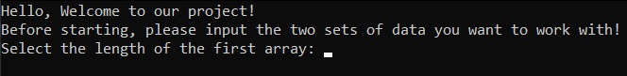

The main menu: The main menu contains list of functions. Every function is unique in their own way. You can learn about the functions and what they do at the bottom of the documentation.

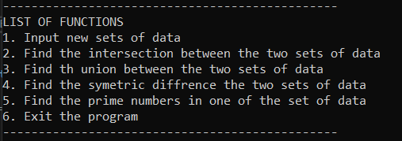

Diagram:

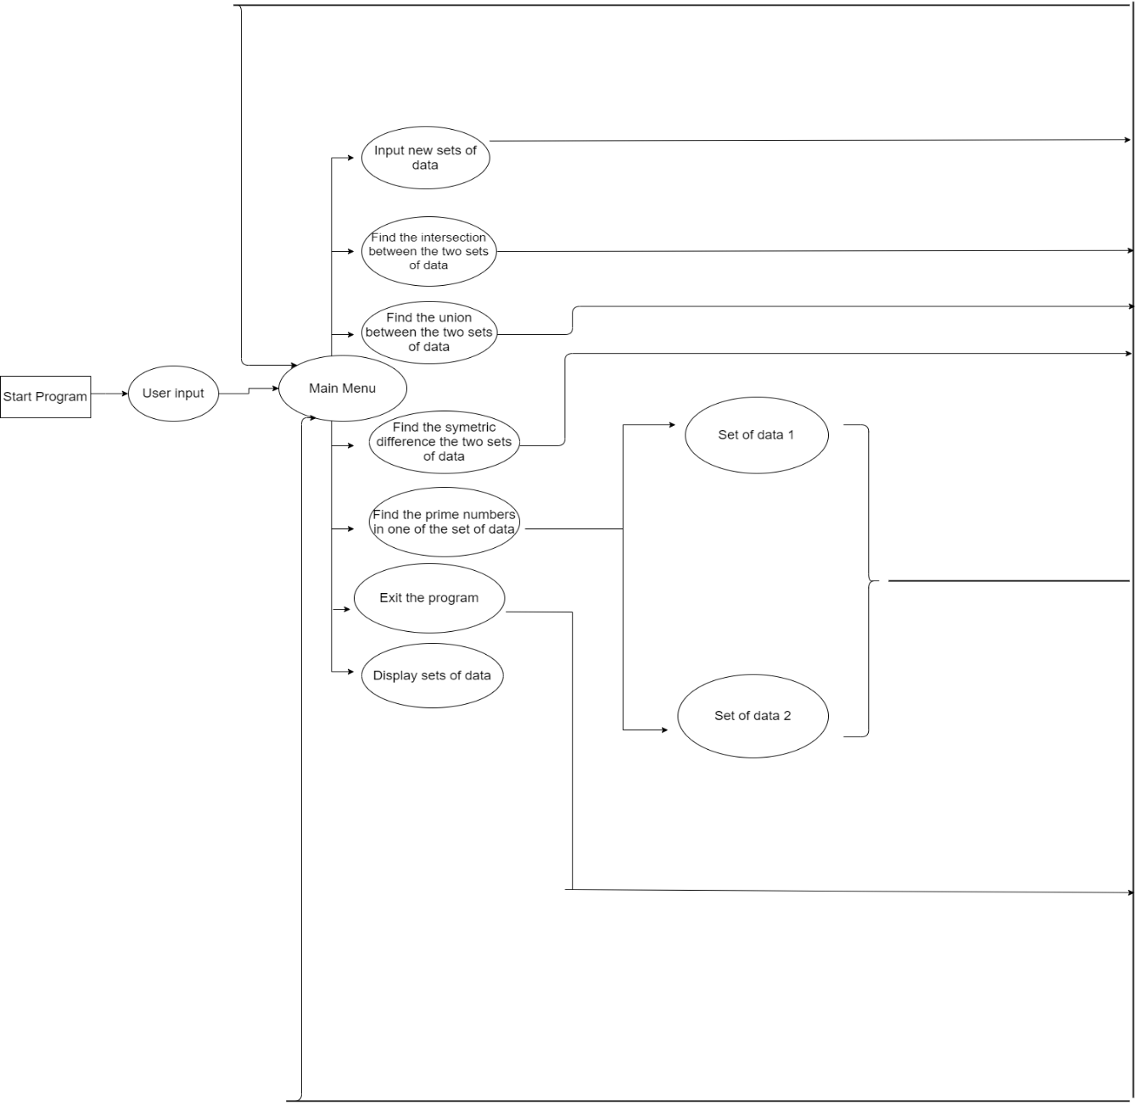

# Explanation of functions

|  |  |  |  |
| --- | --- | --- | --- |
| Function name | Arguments | Purpose | Return value |
| Intersection | int* array1,  int& NumberOfElements1,  int* array2,  int& NumberOfElements2 | Intersects the data in both arrays | Returns data that intersects in both arrays |
| Union | int* array1,  int& NumberOfElements1,  int* array2,  int& NumberOfElements2 | Unites the elements in both arrays | Returns a collection of sets of all elements in both collections |
| SymetricDifference | int* array1,  int& NumberOfElements1  int* array2,  int& NumberOfElements2 | Showing the symmetric defference |  |
| PrimeNumbers | int* array1,  int& NumberOfElements1,  int* array2,  int& NumberOfElements2 | Checks if numbers are prime or not | returns all prime numbers in the first array |
| Input | int* array1  int& NumberOfElements1  int* array2  int& NumberOfElements2 | The User inputs the numbers of elements in both array and the elements | It gives the sets of data the elements that are going to be edited |
| Output | int* array1  int& NumberOfElements1  int* array2  int& NumberOfElements2 | Making the user interface more readable | It returns all elements in both sets of data |
| Menu | int* array1, int& NumberOfElements1, int* array2, int& NumberOfElements2 | Printing and combining |  |
| Greeting | No arguments |  | Prints out a greeting message |
| Exit | No arguments |  | Prints out a greeting message |